Susan Liu

933237062

CS 475

Professor Bailey

5/17/2021

Assignment 5

**The probability of hitting the castle is 10.02% Better than last time!**

1. Tell what machine you ran this on

I ran this on submit-b

2. Show the table and the two graphs

|  |  |  |  |  |  |  |  |  |  |  |
| --- | --- | --- | --- | --- | --- | --- | --- | --- | --- | --- |
|  | 2048 | 4096 | 8192 | 16384 | 32768 | 65536 | 131072 | 262144 | 524288 | 1024000 |
| 16 | 0.064516 | 0.137931 | 0.258065 | 0.516129 | 0.958802 | 1.770095 | 2.917379 | 4.373732 | 5.649655 | 7.144452 |
| 32 | 0.066667 | 0.137931 | 0.258065 | 0.533333 | 1.003922 | 1.943074 | 3.37397 | 5.716678 | 8.074913 | 11.18881 |
| 64 | 0.068966 | 0.137931 | 0.266667 | 0.533333 | 1.026052 | 1.973025 | 3.713509 | 6.558847 | 9.53667 | 14.29848 |
| 128 | 0.066667 | 0.142857 | 0.275862 | 0.533333 | 1.066667 | 2.041874 | 3.864151 | 6.918919 | 9.965937 | 14.23488 |
| 256 | 0.068966 | 0.137931 | 0.275862 | 0.533333 | 1.048106 | 2.100513 | 3.875118 | 7.249558 | 9.828434 | 14.09692 |

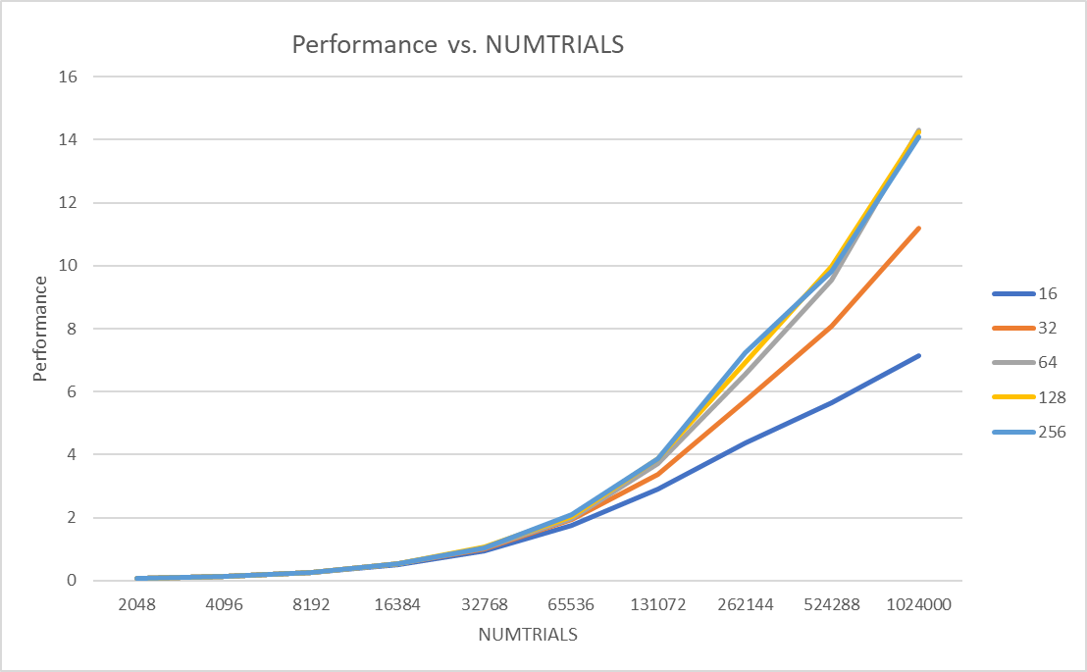

BLOCKSIZE

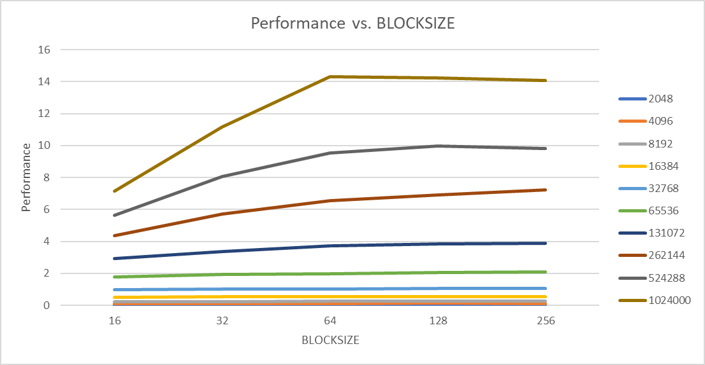

NUMTRIALS

3. What patterns are you seeing in the performance curves?

In the first graph the performance increased before leveling out as BLOCKSIZE increased. In the second graph the performance increased as the NUMTRIALS increased.

4. Why do you think the patterns look this way?

For graph 1, as block size increases the performance time increases before flattening out, this happens to show that if BLOCKSIZE were to increase to an x size the performance time wouldn’t increase but be the same value. I think the reason the graph 2 looks this way is that when NUMTRIALS increases, the performance time increases as well, the bigger the BLOCKSIZE the more time it takes to complete the NUMTRIAL.

5. Why is a BLOCKSIZE of 16 so much worse than the others?

I think the reason BLOCKSIZE 16 is worse than other is because it is not using all to block size. Its like the fruit picker example, if some of the grippers are full you cant pick a lot of fruit right away, it isn’t efficient enough.

6. How do these performance results compare with what you got in Project #1? Why?

Well the graphs in both projects are very similar, I think its because we’re calculating the time it takes for each NUMTRIALS to run in each BLOCKSIZE. In Project 1 we calculate the time it takes to run all the threads. Also taking a closer look at the performance I noticed that project 5’s performance speed (megatrials/sec) is much faster than projects 1’s speed.

7. What does this mean for the proper use of GPU parallel computing?

Having the program being able to efficiently compute the code. Make it quicker more efficient than using threads. There is less user control, regular data structures and flow control.